Observing Genre Codes and Conventions

Using the pictures as a guide, identify technical and symbolic codes and how they relate to media conventions. Provide examples of film you have seen use these same codes and conventions – Are they also the same genre?
The first example has been done for you.
Picture Examples | Codes  Technical Symbolic |  | Conventions | Film Examples
Science Fiction  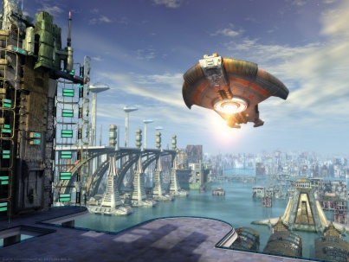 | Long shot of futuristic city. Maybe alien planet?  Low angle shot. Perhaps suggesting spaceship or people on it are powerful.  Framed so that spaceship is just of centre, frames on 2 sides by building and landing platform.  Special effects: The whole shot is computer animated. | Colour: Lots of blues, greys, brown-y greens and undertones of lighter colours e.g. yellow and white. Spaceship is brightest, most significant – draws attention.  Setting: From the shape and structure of the buildings it appears to be a futuristic city or alien world.  Appearance: other worldly, but colours suggest not hostile. | - Space/futuristic setting.  - Greys, browns.  - Special effects and animations.  In my experience these are all common conventions of science fiction films.  Light colours not so common in traditional science fiction films. | Avatar – Yes  Golden Compass -  Genre seems half Sci-Fi half family
Horror
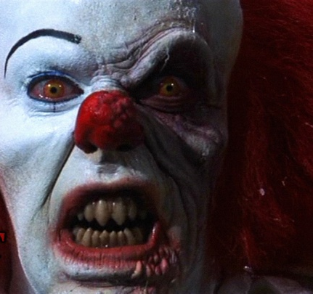
Drama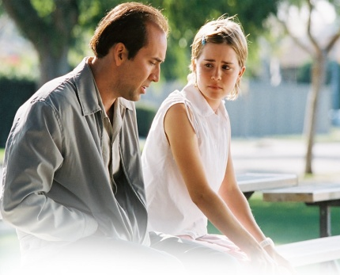
Adventure
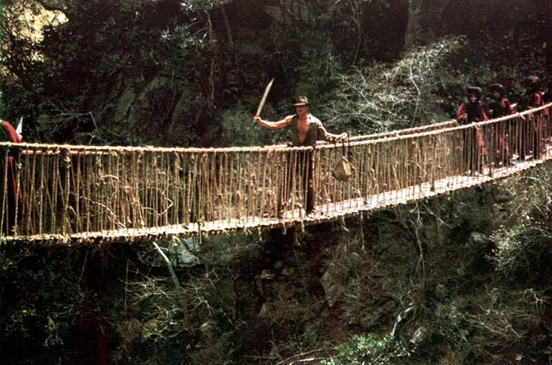
Family
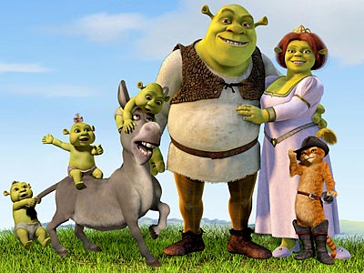
Action
